**CS 255 System Design Document**

**UML Diagrams**

**UML Use Case Diagram**

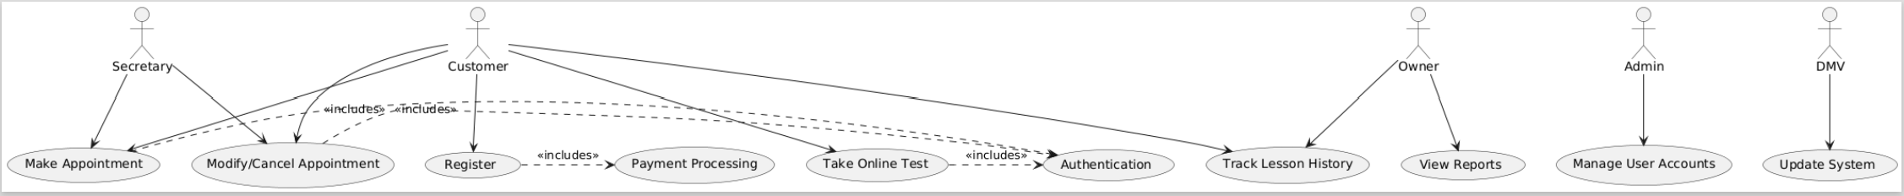

**UML Activity Diagrams**

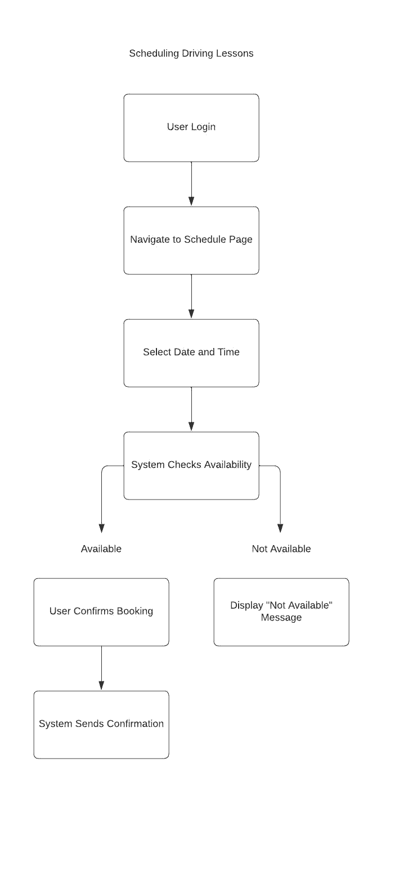

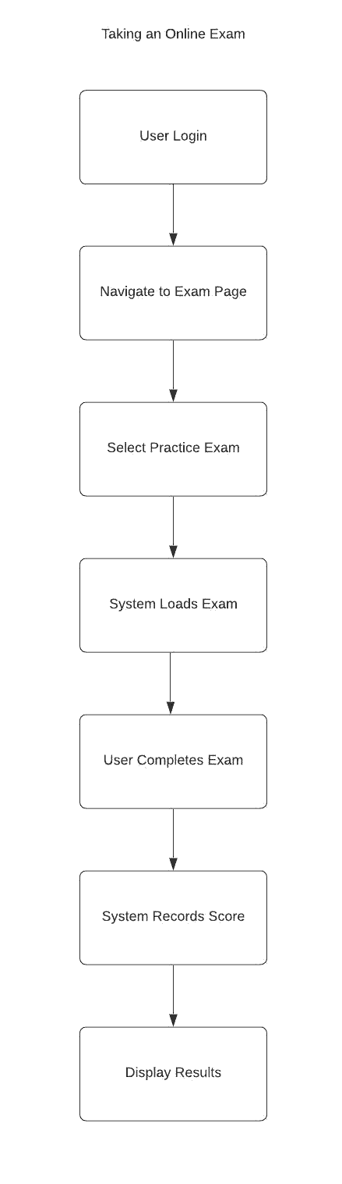

**UML Sequence Diagram**

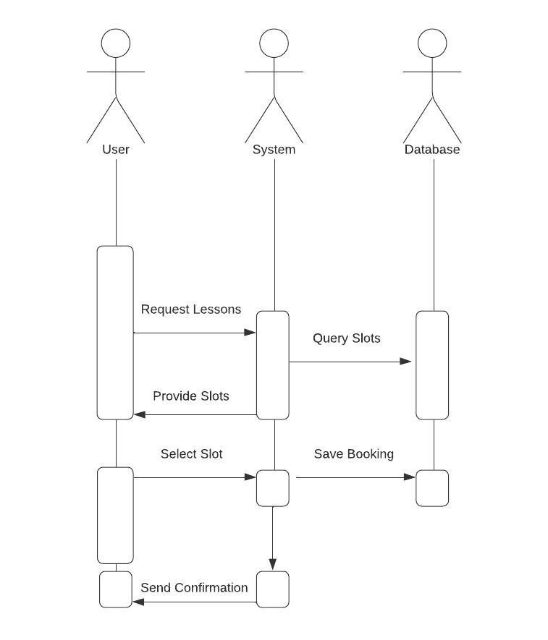

*Scheduling Driving Lessons*

**UML Class Diagram**

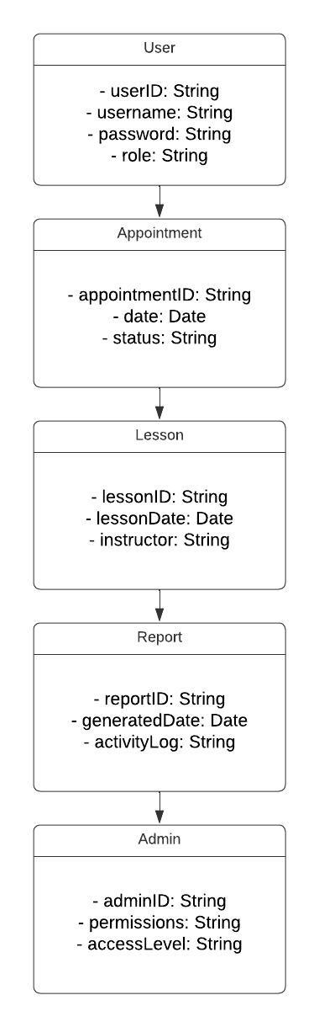

**Technical Requirements**

The DriverPass system will require a cloud-based infrastructure for supporting web and mobile accessibility. It will be hosted on scalable and reliable cloud servers such that desktops or mobile devices will access the platform. For user information storage, lesson appointments, and reports, cloud-based storage solutions such as Firebase and MySQL would be used. This makes sure that data management is secure, efficient, and scalable.

The system frontend will be designed on the software side using the following web technologies: HTML, CSS, and JavaScript. This will provide an interactive interface to customers, secretaries, and administrators. The use of Node.js or Python will be applied in designing the backend to allow for server-side processing, authentication of users, lesson scheduling, and report generation. It will also include a secure login solution with encrypted passwords and SSL certificates for data protection.

Some other tools and infrastructures include the use of a program for producing UML diagrams such as Lucid Chart; this, in turn, would be supported with Continuous Integration Pipelines, staging areas that make sure of minimal disruption to the users when the system is updated or bugs are fixed. Since there will be sensitive data stored, security would be a priority to this system, enabling varied protections that stop unauthorized access, data breaches, and brute-force attempts at login.